Table of Contents

1 Table of Figures 1

2 Table of Tables 1

3 Table of Equations 1

3.1 Approach and Execution 2

4 Bibliography 6

# Table of Figures

Figure 1: Exoskeleton Abstraction 2

Figure 2: 3 DOF RRR Parameterisation 2

# Table of Tables

No table of figures entries found.

# Table of Equations

Equation 1: 3 DOF Revolute Manipulator Jacobian 4

Equation 2: Inertia Tensors 4

Equation 3: Mass Matrix for the 3 DOF Revolute Manipulator 4

Equation 4: Vector of Centrifugal Forces 5

Equation 5: Vector of Coriolis Force 5

# 

## Approach and Execution

Before the kinematics of the system could be found, the exoskeleton needed to be abstracted into a model. Consider the following:

1. The exoskeleton is to be affixed to the lower torso of the pilot;
2. The pilot is presumed to maintain the balance of the system using their body;
3. The pilot should be able to manipulate the legs of the system independently;
4. The legs, while part of the same exoskeletons, are essentially fixed at the pelvis and operate independently; and,
5. We may therefore consider each leg as an independent manipulator with a fixed reference frame at the pelvis.

As noted in kt, each joint of the exoskeleton shall be constrained to 1 DOF. Therefore, we may abstract the exoskeleton as two 3 DOF RRR manipulators, as seen in Figure 1: Exoskeleton Abstraction.

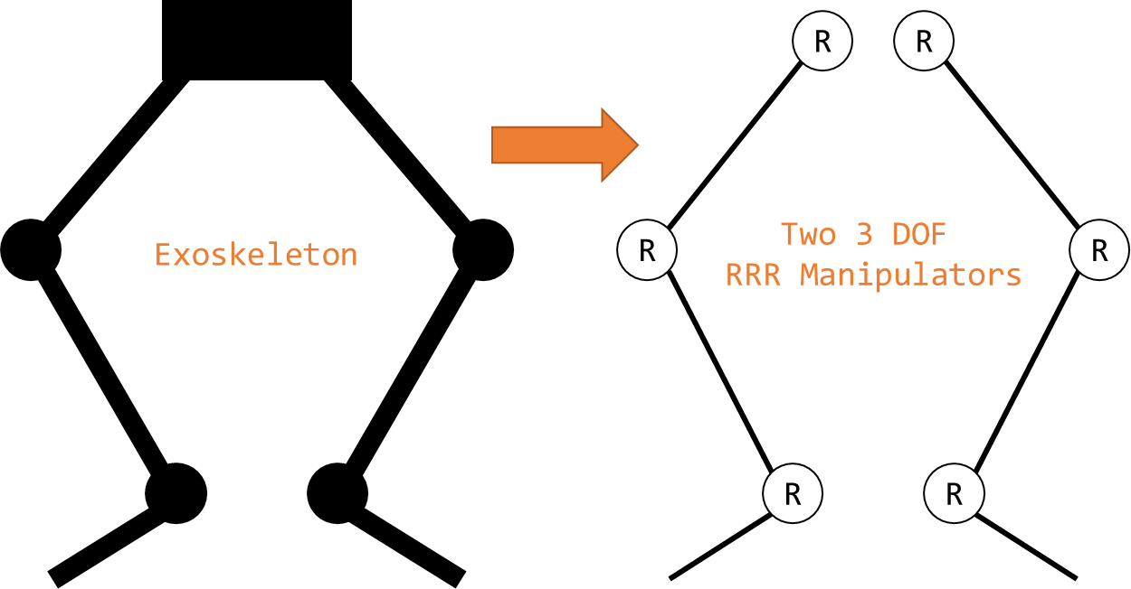

Figure 1: Exoskeleton Abstraction

For modelling the system, the parameters seen in Figure 2: 3 DOF RRR Parameterisation shall be used. Note angle shall be measured relative to the previous link with a clockwise positive convention.

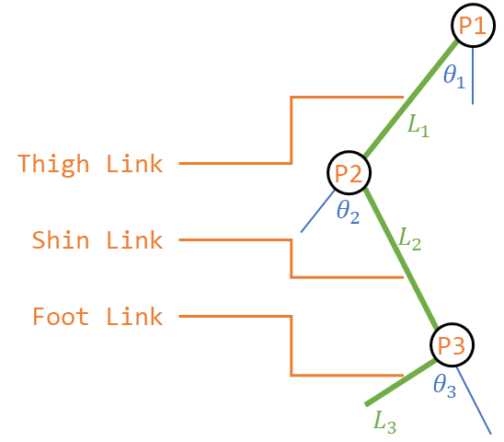

Figure 2: 3 DOF RRR Parameterisation

As noted in kt (requirements section) the actual values for the exoskeleton were never confirmed and the controls had to be completed symbolically. On one hand, this resulted in a general solution that can be applied to any 3 DOF RRR serial manipulator. On the other hand, the equations become cumbersome and large. As a result, many of the equations shall be taken to their general form, as explicit solutions shall be left as an exercise to the reader.

### Jacobian

To find the Jacobian of a 3 DOF Revolute Manipulator:

$$v=System Velocity$$

$${{}_{ }^{0}v}_{P_{1}}=ω_{1}*P_{1}$$

$${{}_{ }^{0}v}_{P_{2}}={{}_{ }^{0}v}_{P_{1}}+ω_{2}*P_{2}$$

$${{}_{ }^{0}v}_{P_{3}}={{}_{ }^{0}v}_{P_{2}}+ω_{3}*P_{3}$$

Or, for a system at low velocity (i.e. standing, squatting, sitting, stairs, walking):

$${{}_{ }^{0}v}_{P_{1}}=\left[\begin{matrix}0 & -{\dot{θ}}_{1} & 0 \\ {\dot{θ}}_{1} & 0 & 0 \\ 0 & 0 & 0\end{matrix}\right]\left[\begin{matrix}L_{1}c_{1} \\ L_{1}s_{1} \\ 0\end{matrix}\right]=\left[\begin{matrix}-L_{1}s_{1} \\ L_{1}c_{1} \\ 0\end{matrix}\right]{\dot{θ}}_{1}$$

$${{}_{ }^{0}v}_{P_{2}}={{}_{ }^{0}v}_{P_{1}}+\left[\begin{matrix}0 & -({\dot{θ}}_{1}+{\dot{θ}}_{2}) & 0 \\ ({\dot{θ}}_{1}+{\dot{θ}}_{2}) & 0 & 0 \\ 0 & 0 & 0\end{matrix}\right]\left[\begin{matrix}L_{2}c_{12} \\ L_{2}s_{12} \\ 0\end{matrix}\right]=\left[\begin{matrix}-L_{1}s_{1} \\ L_{1}c_{1} \\ 0\end{matrix}\right]{\dot{θ}}_{1}+\left[\begin{matrix}-L_{2}s_{12} \\ L_{2}c_{12} \\ 0\end{matrix}\right]({\dot{θ}}_{1}+{\dot{θ}}_{2})$$

$${{}_{ }^{0}v}_{P_{2}}={{}_{ }^{0}v}_{P_{1}}+{{}_{ }^{0}v}_{P_{2}}+\left[\begin{matrix}0 & -({\dot{θ}}_{1}+{\dot{θ}}_{2}+{\dot{θ}}_{3}) & 0 \\ ({\dot{θ}}_{1}+{\dot{θ}}_{2}+{\dot{θ}}_{3}) & 0 & 0 \\ 0 & 0 & 0\end{matrix}\right]\left[\begin{matrix}L_{3}c_{123} \\ L_{3}s_{123} \\ 0\end{matrix}\right]=\left[\begin{matrix}-L_{1}s_{1} \\ L_{1}c_{1} \\ 0\end{matrix}\right]{\dot{θ}}_{1}+\left[\begin{matrix}-L_{2}s_{12} \\ L_{2}c_{12} \\ 0\end{matrix}\right]\left({\dot{θ}}_{1}+{\dot{θ}}_{2}\right)+\left[\begin{matrix}-L_{3}s_{123} \\ L_{3}c_{123} \\ 0\end{matrix}\right]\left({\dot{θ}}_{1}+{\dot{θ}}_{2}+{\dot{θ}}_{3}\right)$$

In matrix form

$${{}_{ }^{0}v}_{P_{1}}=\left[\begin{matrix}-l_{1}s_{1} & 0 & 0 \\ l_{1}c_{1}0 & 0 & 0 \\ 0 & 0 & 0\end{matrix}\right]\left[\begin{matrix}{\dot{θ}}_{1} \\ {\dot{θ}}_{2} \\ {\dot{θ}}_{3}\end{matrix}\right]$$

$${{}_{ }^{0}v}_{P_{2}}=\left[\begin{matrix}-\left(l_{1}s_{1}+l_{2}s_{12}\right) & -l_{2}s_{12} & 0 \\ l_{1}c_{1}+l_{2}c_{12} & -l_{2}c_{12} & 0 \\ 0 & 0 & 0\end{matrix}\right]\left[\begin{matrix}{\dot{θ}}_{1} \\ {\dot{θ}}_{2} \\ {\dot{θ}}_{3}\end{matrix}\right]$$

$${{}_{ }^{0}v}_{P_{2}}=\left[\begin{matrix}-\left(l_{1}s_{1}+l_{2}s_{12}+l_{3}s_{123}\right) & -{(l}_{2}s_{12}+l_{3}s_{123}) & -l_{3}s_{123} \\ l_{1}c_{1}+l_{2}c_{12}+l_{3}c_{123} & -l_{2}c_{12}+l_{3}c_{123} & l_{3}c_{123} \\ 0 & 0 & 0\end{matrix}\right]\left[\begin{matrix}{\dot{θ}}_{1} \\ {\dot{θ}}_{2} \\ {\dot{θ}}_{3}\end{matrix}\right]$$

The angular velocities are simply additive:

$${{}_{ }^{0}ω}_{1}=\left[\begin{matrix}0 & 0 & 0 \\ 0 & 0 & 0 \\ 1 & 0 & 0\end{matrix}\right]\left[\begin{matrix}{\dot{θ}}_{1} \\ {\dot{θ}}_{2} \\ {\dot{θ}}_{3}\end{matrix}\right]$$

$${{}_{ }^{0}ω}_{2}=\left[\begin{matrix}0 & 0 & 0 \\ 0 & 0 & 0 \\ 1 & 1 & 0\end{matrix}\right]\left[\begin{matrix}{\dot{θ}}_{1} \\ {\dot{θ}}_{2} \\ {\dot{θ}}_{3}\end{matrix}\right]$$

$${{}_{ }^{0}ω}_{3}=\left[\begin{matrix}0 & 0 & 0 \\ 0 & 0 & 0 \\ 1 & 1 & 1\end{matrix}\right]\left[\begin{matrix}{\dot{θ}}_{1} \\ {\dot{θ}}_{2} \\ {\dot{θ}}_{3}\end{matrix}\right]$$

From which we obtain the Jacobian of a 3 DOF Revolute Manipulator, as seen in Equation 1.

$$\left(\begin{matrix}v \\ ω\end{matrix}\right)=J\left(\begin{matrix}{\dot{θ}}_{1} \\ {\dot{θ}}_{2} \\ {\dot{θ}}_{3}\end{matrix}\right)$$

Equation 1: 3 DOF Revolute Manipulator Jacobian

### Dynamics

For a 3 DOF Revolute Manipulator where the inertia tensors of the links are $I_{1}$, $I_{2}$, and $I_{3}$ (Equation 2).

$${{}_{ }^{1}I}_{1}=\left(\begin{matrix}I_{xx1} & 0 & 0 \\ 0 & I_{yy1} & 0 \\ 0 & 0 & I_{zz1}\end{matrix}\right)\& {{}_{ }^{2}I}_{2}=\left(\begin{matrix}I_{xx2} & 0 & 0 \\ 0 & I_{yy2} & 0 \\ 0 & 0 & I_{zz2}\end{matrix}\right)\& {{}_{ }^{3}I}_{3}=\left(\begin{matrix}I_{xx3} & 0 & 0 \\ 0 & I_{yy3} & 0 \\ 0 & 0 & I_{zz3}\end{matrix}\right)$$

Equation 2: Inertia Tensors

#### Explicit form of Manipulator Mass Matrix

The mass matrix for the 3 DOF Revolute Manipulator is given by Equation 3. This process was completed with symbolic variables in MATLAB R2017b, as detailed in the attached files (get_EOM.m) kt.

$$M=m_{1}J_{v1}^{T}J_{v1}+J_{ω1}^{T}I_{1}J_{ω1}^{ }+m_{2}J_{v2}^{T}J_{v2}+J_{ω2}^{T}I_{2}J_{ω2}^{ }+m_{3}J_{v3}^{T}J_{v3}+J_{ω3}^{T}I_{3}J_{ω3}^{ }$$

Equation 3: Mass Matrix for the 3 DOF Revolute Manipulator

#### Vector of centrifugal and Coriolis forces

We begin with **Error! Reference source not found.**.

$$C\left(q\right)=\left[\begin{matrix}b_{111} & b_{122} & … & b_{1nn} \\ b_{211} & b_{222} & … & b_{2nn} \\ ⋮ & ⋮ & ⋱ & ⋮ \\ b_{n11} & b_{n22} & … & b_{nnn}\end{matrix}\right]$$

$$C\left(q\right)=\left[\begin{matrix}b_{111} & b_{122} & b_{133} \\ b_{211} & b_{222} & b_{233} \\ b_{311} & b_{322} & b_{333}\end{matrix}\right]$$

$$C\left(q\right)=\left[\begin{matrix}0 & \frac{1}{2}\left(m_{122}+m_{122}-m_{221}\right) & \frac{1}{2}\left(m_{133}+m_{133}-m_{331}\right) \\ \frac{1}{2}\left(m_{211}+m_{211}-m_{112}\right) & 0 & \frac{1}{2}\left(m_{233}+m_{233}-m_{332}\right) \\ \frac{1}{2}\left(m_{311}+m_{311}-m_{113}\right) & \frac{1}{2}\left(m_{322}+m_{322}-m_{223}\right) & 0\end{matrix}\right]$$

Equation 4: Vector of Centrifugal Forces

Next **Error! Reference source not found.**.

$$B\left(q\right)=\left[\begin{matrix}2b_{112} & 2b_{113} & … & 2b_{11n} & 2b_{123} & … & 2b_{12n} & … & 2b_{1\left(n-1\right)n} \\ 2b_{212} & 2b_{213} & … & 2b_{21n} & 2b_{223} & … & 2b_{22n} & … & 2b_{2\left(n-1\right)n} \\ ⋮ & ⋮ & ⋮ & ⋮ & ⋮ & ⋮ & ⋮ & ⋱ & ⋮ \\ 2b_{n12} & 2b_{n13} & … & 2b_{n1n} & 2b_{n23} & … & 2b_{n2n} & … & 2b_{n\left(n-1\right)n}\end{matrix} \right]$$

$$B\left(q\right)=\left[\begin{matrix}2b_{112} & 2b_{113} & 2b_{123} \\ 2b_{212} & 2b_{213} & {2b}_{223} \\ 2b_{312} & 2b_{313} & {2b}_{323}\end{matrix} \right]$$

$$B\left(q\right)=\left[\begin{matrix}m_{112} & m_{113} & \left(m_{123}+m_{132}-m_{231}\right) \\ 0 & \left(m_{213}+m_{231}-m_{132}\right) & m_{223} \\ \left(m_{312}+m_{321}-m_{123}\right) & 0 & 0\end{matrix} \right]$$

Equation 5: Vector of Coriolis Force

From **Error! Reference source not found.**

$$b_{ijk}=\frac{1}{2}\left(m_{ijk}+m_{ikj}-m_{jki}\right)→b_{iii}=b_{iji}=0$$

Where

$$m_{ijk}=\frac{∂m_{ij}}{∂q_{k}} \left(m_{ij}=M_{ij}\right)$$

This process was completed with symbolic variables in MATLAB R2017b, as detailed in the attached files (get_EOM.m) kt.

# Bibliography

Agarwal, A. (2005). *Foundations of analog & digital electronic circuits* (1 ed.). Massachusetts: Massachusetts Institute of Technology. Retrieved June 1, 2018, from https://www.google.com/url?sa=t&rct=j&q=&esrc=s&source=web&cd=1&ved=0ahUKEwiBu7yQl7LbAhUEoZQKHfYlBzkQFggpMAA&url=http%3A%2F%2Fsiva.bgk.uni-obuda.hu%2Fjegyzetek%2FMechatronikai_alapismeretek%2FEnglish_Mechatr%2FElectr_Eng-1%2FLiterature%2FFoundations%2520o

American Technologies Network Corporation. (2018, May 30). *How Does Night Vision Work*. Retrieved from atncorp.com: https://www.atncorp.com/hownightvisionworks

Arrow. (2018). *Magnetoresistive Sensor.* Retrieved May 30, 2018, from arrow.com: https://www.arrow.com/en/categories/sensors/magnetoresistive-sensors

Axe, D. (2012, May 23). *Combat Exoskeleton Marches Toward Afghanistan Deployment*. Retrieved May 30, 2018, from Wired: https://www.wired.com/2012/05/combat-exoskeleton-afghanistan/

Bulgrin, M. (2017, May 11). *The History of the Hose Clamp.* Retrieved from normagroup.com: https://blog.normagroup.com/en/the-history-of-the-hose-clamp/

Bunnings. (2018, May 31). *Kinetic 21 - 44mm 304 Stainless Steel Hose Clamp.* Retrieved May 31, 2018, from Bunnings.com: https://www.bunnings.com.au/kinetic-21-44mm-304-stainless-steel-hose-clamp_p4920194

Charara, S. (2015, July 9). *This robotic exoskeleton helps paralysed patients to walk and it's getting smarter*. Retrieved August 23, 2017, from Wearable: https://www.wareable.com/wearable-tech/exoskeleton-paralysed-patients-ekso-bionics-gt-sarah-thomas

Computer Cable Store. (2018, May 31). *11 7/8 Inch Black Standard Nylon Cable Tie - 100 Pack.* Retrieved May 31, 2018, from computercablestore.com: https://www.computercablestore.com/11-78-inch-black-standard-nylon-cable-tie-100-pack

Cornwall, W. (2015, October 15). *Feature: Can we build an ‘Iron Man’ suit that gives soldiers a robotic boost?* Retrieved August 20, 2017, from sciencemag.org: http://www.sciencemag.org/news/2015/10/feature-can-we-build-iron-man-suit-gives-soldiers-robotic-boost

Cracknell, A. P., & Hayes, L. (2007). *Introduction to Remote Sensing* (2 ed.). London: Taylor and Francis. Retrieved May 30, 2018

Cutnell, J. D., & Johnson, K. W. (1998). *Physics* (4th ed.). New York: Wiley.

Cyberdyne. (2015, August 1). *CYBERDYNE Inc. has begun seeking approval from the U. S. Food and Drug Administration (FDA)*. Retrieved August 23, 2017, from cyberdyne.jp: https://www.cyberdyne.jp/english/company/PressReleases_detail.html?id=1075

Cyberdyne. (2016). *What’s HAL?* Retrieved August 19, 2017, from cyberdyne.jp: https://www.cyberdyne.jp/english/products/HAL/

Cybernetic Zoo. (2010, October 14). *1890 – Assisted-walking Device – Nicholas Yagn (Russian)*. Retrieved May 30, 2018, from Cyberneticzoo.com: http://cyberneticzoo.com/tag/nicholas-yagn/

Cybernetic Zoo. (2010, April 10). *1965-71 – G.E. Hardiman I Exoskeleton – Ralph Mosher (American)*. Retrieved May 30, 2018, from cyberneticzoo.com: http://cyberneticzoo.com/man-amplifiers/1966-69-g-e-hardiman-i-ralph-mosher-american/

Dawkins, P. (2018). *Differential Equations - Notes - Laplace’s Equation*. Retrieved June 3, 2018, from Paul's Online Math Notes: http://tutorial.math.lamar.edu/Classes/DE/LaplacesEqn.aspx

Dunietz, J. (2017, July 27). *Robotic Exoskeleton Adapts While It’s Worn*. Retrieved August 20, 2017, from scientificamerican.com: https://www.scientificamerican.com/article/robotic-exoskeleton-ldquo-evolves-rdquo-while-its-worn/

Future Electronics. (2018, May 30). *What is Optoelectronics?* Retrieved from Future Electronics: http://www.futureelectronics.com/en/optoelectronics/infrared-receivers.aspx

Garbett, I. (2001, Janurary 1). *Light attenuation and exponential laws*. Retrieved May 30, 2018, from plus.maths.org: https://plus.maths.org/content/light-attenuation-and-exponential-laws

Golnaraghi, F., & Kuo, B. C. (2010). *Automatic Control Systems* (9 ed.). Hoboken: John Wiley & Sons, Inc. Retrieved June 4, 2018

Gross, K. (2018, Feburary 19). *Ultrasonic Sensors: Advantages and Limitations*. Retrieved May 30, 2018, from MaxBotix: https://www.maxbotix.com/articles/advantages-limitations-ultrasonic-sensors.htm/

Jackson, R., Green, K. R., & Eisenbeis, R. (2017). *Achieve greater precision, reliability with integrated magnetic sensing technology.* Retrieved May 30, 2018, from ti.com: http://www.ti.com/general/docs/lit/getliterature.tsp?baseLiteratureNumber=sszy030&fileType=pdf

Karlin, S. (2011, July 29). *Raytheon Sarcos’s Exoskeleton Nears Production*. Retrieved August 11, 2017, from spectrum.ieee.org: http://spectrum.ieee.org/at-work/innovation/raytheon-sarcoss-exoskeleton-nears-produc

Keller, M. (2016, August 25). *Exoskeleton - Do You Even Lift, Bro? Hardiman Was GE’s Muscular Take On The Human-Machine Interface*. (General Electric) Retrieved May 30, 2018, from GE Reports: https://www.ge.com/reports/do-you-even-lift-bro-hardiman-and-the-human-machine-interface/

Keyence Corporation. (2018). *What is a Inductive Proximity Sensor?* Retrieved May 30, 2018, from keyence.com: https://www.keyence.com/ss/products/sensor/sensorbasics/proximity/info/

Khatib, O. (2008). Chapter 5 - Dynamics. In O. Khatib, *Introduction to Robotics* (pp. 125-150). Stanford: Stanford University.

Liew, S. C. (2018, May 30). *Electromagnetic Waves*. Retrieved from Centre for Remote Imaging, Sensing and Processing.: https://crisp.nus.edu.sg/~research/tutorial/em.htm

Lynch, D. K., & Livingston, W. C. (2001). *Color and Light in Nature* (2nd ed.). Cambridge, United Kingdom: Cambridge University Press. Retrieved May 30, 2018, from https://books.google.com.au/books?id=4Abp5FdhskAC&pg=PA231&redir_esc=y#v=onepage&q&f=false

Merriam-Webster Dictionary. (2018, May 18). *noise*. Retrieved May 30, 2018, from merriam-webster.com: https://www.merriam-webster.com/dictionary/noise

National Instruments. (2018). *PID Theory Explained.* Retrieved June 4, 2018, from NationalInstruments.com: http://www.ni.com/white-paper/3782/en/

Ogata, K. (2010). *Modern Control Engineering* (2 ed.). New Jersey, United States of America: Prentice Hall. Retrieved August 25, 2017

Otaga, K. (2004). *System Dynamics* (4 ed.). Upper Saddle River: Pearson. Retrieved June 4, 2018

Robomart. (2015, November 9). *Advantages and Disadvantages of ultrasonic distance sensor.* Retrieved May 30, 2018, from Robomart: http://roboticsensors.blogspot.com/2015/11/advantages-and-disadvantages-of.html

Siciliano, B., & Khatib, O. (2016). *Springer Handbook of Robotics* (2 ed.). (B. Siciliano, & O. Khatib, Eds.) Berlin: Springer Nature. doi:10.1007/978-3-319-32552-1

Texas Instruments Incorporated. (2017). *Hall effect sensors*. Retrieved May 30, 2018, from ti.com: http://www.ti.com/sensing-products/magnetic-sensors/hall-effect/overview.html

Thomas Publishing Company. (2018). *Capacitive Proximity Sensors*. Retrieved May 30, 2018, from Thomas: https://www.thomasnet.com/articles/instruments-controls/proximity-sensors

Vishay Semiconductors. (2017, February 8). TCRT5000 - Reflective Optical Sensor with Transistor Output.

Yagin, N. (1890, February 11). *United States of America Patent No. 440684.*

Yuhas, D. (2012, May 24). *Speedy Science: How Fast Can You React?* Retrieved from scientificamerican.com: https://www.scientificamerican.com/article/bring-science-home-reaction-time/

ZJIA. (2018, June 1). *Generic YZC-161B 50kg Body Scale Sensor Human Scale Weighing Load Cell Sensor (Pack of 4)* . Retrieved June 1, 2018, from Amazon.com: https://www.amazon.com/Generic-YZC-161B-Scale-Sensor-Weighing/dp/B00MTJ6WZ2